**Using QEMU on Windows: Setting Up a Virtual Machine with WHPX Accelerator**

Hello! Today, I will talk about installing the QEMU application on Windows. Let's first take a look at what QEMU is.

QEMU (Quick EMUlator) is an open-source and free system emulator and virtualization software. It allows you to run operating systems and applications designed for different processor architectures and hardware platforms.

KVM (Kernel-based Virtual Machine) is a virtualization technology developed for the Linux operating system. QEMU works in integration with KVM, allowing virtual machines to run directly on the hardware and achieve high performance.

An accelerator is a technology that QEMU uses to improve the performance of virtual machines. In addition to KVM, other accelerators like Xen, Hypervisor Framework (hvf), and Windows Hypervisor Platform (whpx) are also supported.

WHPX (Windows Hypervisor Platform) is a virtualization accelerator developed for the Windows operating system. By using WHPX, QEMU can enhance the performance of virtual machines running on Windows.

In summary, QEMU works with accelerators like KVM, Xen, hvf, and WHPX to allow you to create high-performance virtual machines across different platforms and emulate various operating systems.

Now, let's look at how to install QEMU on a Windows computer. There are multiple ways to install QEMU on Windows. You can use WSL, MSYS, or directly download the setup file from QEMU's website.

First, go to this website: <https://qemu.weilnetz.de/w64/>

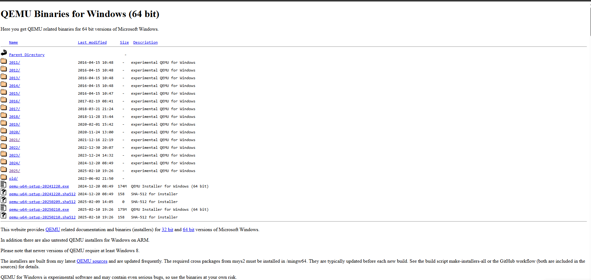

Figure 1 <https://qemu.weilnetz.de/w64/>

On this website, QEMU provides a database of previous and the latest versions for Windows. From here, I downloaded two versions for testing purposes. One is the latest version, and the other is version 20210208. This is because the WHPX accelerator we will be using causes an injection error after version 20210208. However, this is not a bug. We will continue with the 20210208 version. Now, let's click on the "2021" folder on the site above.

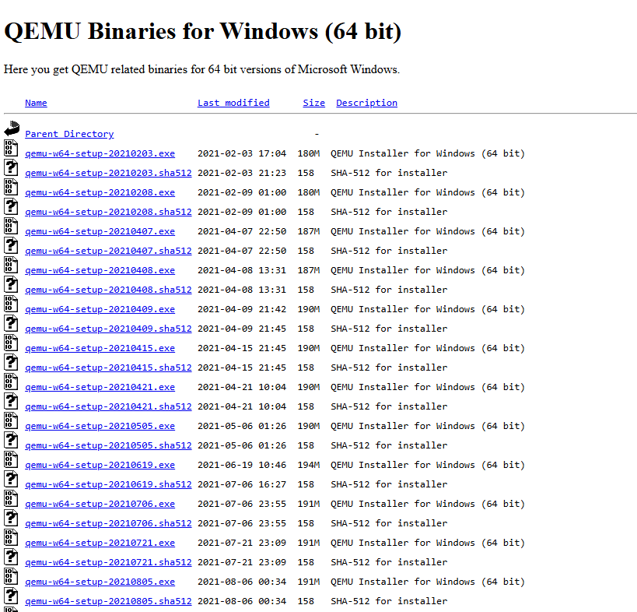

Figure 2"2021" folder

Next, let's download the version released on February 8th, 2021, which is the 20210208 version, from this site and run it.

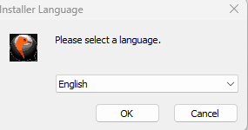

Then, click "OK" to proceed and follow the instructions below.

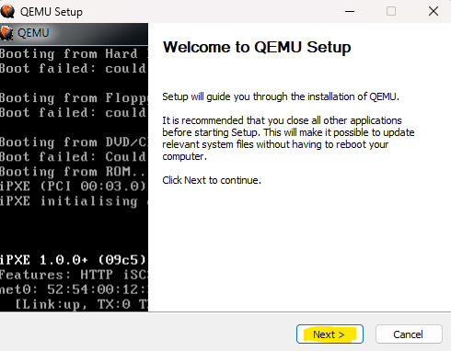

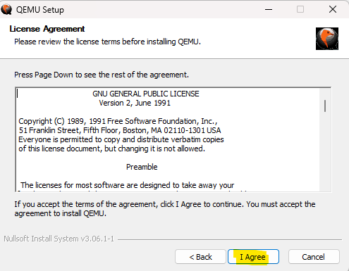

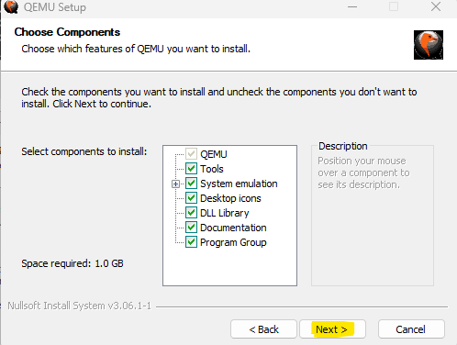

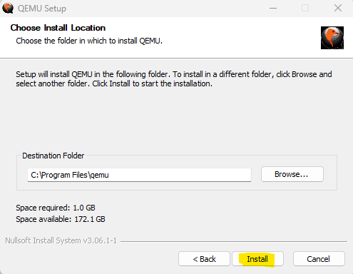

After these steps, QEMU will be installed under the C:\Program Files\qemu folder.

Now, to run QEMU, open PowerShell as an administrator and use the following commands to navigate to the QEMU directory:

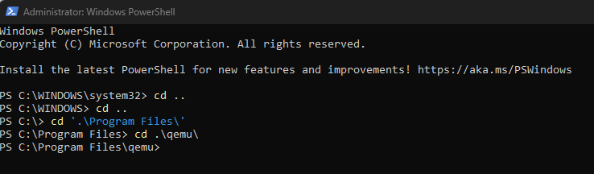

Now that we are in the QEMU folder, we have access to the application files for qemu-img and qemu-system-x86_64.

Let's first talk about the types of disks available in QEMU:

QEMU supports various disk image formats in the field of virtualization and emulation. These formats are designed for different needs and use cases. The **Raw** format is the most basic disk image format and directly mirrors every sector on the disk. This provides high performance but lacks advanced features. For example, it does not support features like snapshots.

**QCOW2** (QEMU Copy On Write 2) is QEMU's advanced disk image format and comes with many useful features. The "copy-on-write" mechanism ensures that only the modified data is stored, which saves disk space. It also supports features like encryption and compression, improving security and storage efficiency. With snapshot support, you can save the state of virtual machines at any given point and revert to that state if necessary.

QEMU also supports disk image formats from other virtualization platforms, such as **VDI** (VirtualBox), **VMDK** (VMware), and **VHD** (Hyper-V). This ensures compatibility between different platforms and allows for disk image conversions.

Each disk image format has its own advantages and limitations. The Raw format offers high performance, while QCOW2 provides advanced features and flexibility. Other formats offer compatibility and portability for specific platforms.

Now, let's continue by creating a QCOW2 disk. We can create a 20GB disk in this format by entering the following command in PowerShell:

**.\qemu-img create -f qcow2 disk.qcow2 20G**

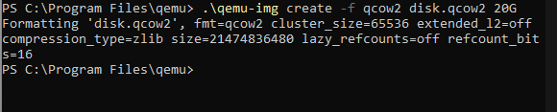

Our disk named **disk.qcow2** has been successfully created with a size of 20GB.

Now, if you want, we can proceed to install Windows 10 on this disk using the WHPX accelerator. Let's configure and write the command below according to our needs:

**.\qemu-system-x86_64 -drive file=disk.qcow2,format=qcow2 -accel whpx -drive file="C:\Users\reqwe\Downloads\win10.iso",media=cdrom -drive file="C:\Users\reqwe\Desktop\virtio-win-0.1.266.iso",media=cdrom -boot d -m 8G -cpu Westmere**

Here’s a breakdown of the command you're using and its components:

* **.\qemu-system-x86_64**: This runs the QEMU version for the 64-bit x86 architecture. In a Windows environment, this command is used in the directory where QEMU is installed.
* **-drive file=disk.qcow2,format=qcow2**: This specifies the disk image to use, in this case, **disk.qcow2**. It uses the QCOW2 format, which is QEMU's advanced disk image format that supports features like snapshots and encryption.
* **-accel whpx**: Enables Windows Hypervisor Platform (WHPX) acceleration. WHPX is used to improve the virtual machine's performance. It is available in Windows 10 and Windows Server 2016 and later versions.
* **-drive file="C:\Users\reqwe\Downloads\win10.iso",media=cdrom**: This connects the Windows 10 installation ISO to the first CD-ROM drive of the virtual machine. It allows the virtual machine to boot from the Windows 10 installation media.
* **-drive file="C:\Users\reqwe\Desktop\virtio-win-0.1.266.iso",media=cdrom**: This connects the VirtIO drivers ISO to the second CD-ROM drive. VirtIO provides high-performance I/O operations for virtual machines.
* **-boot d**: This tells the virtual machine to boot from the CD-ROM drive (where the Windows 10 ISO is located) first. This is necessary to start the operating system installation process.
* **-m 8G**: Allocates 8GB of RAM to the virtual machine. This defines the amount of memory the virtual machine will use.
* **-cpu Westmere**: Sets the CPU of the virtual machine to the Intel Westmere architecture. This is used to emulate specific CPU features and improve compatibility with certain operating systems.

With this setup, you’re configuring a virtual machine that will boot from the Windows 10 ISO to start the installation process and use VirtIO drivers for enhanced I/O performance.

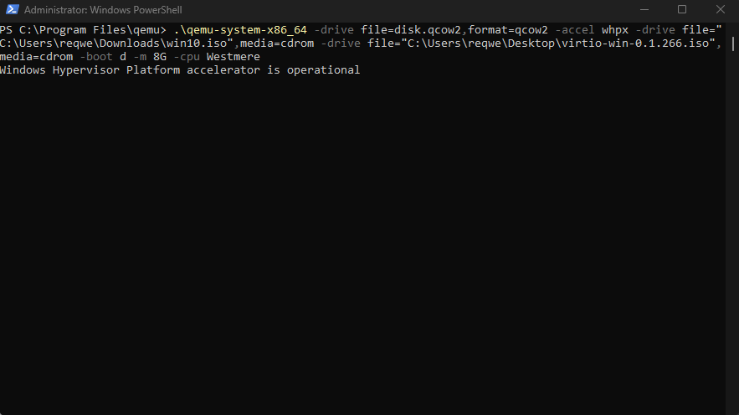

Great! The virtual machine has successfully started. Now you can proceed with the Windows 10 installation process, and once it's completed, your virtual machine should be fully set up and ready to use.

We're proceeding with the installation information, customizing it according to our needs.

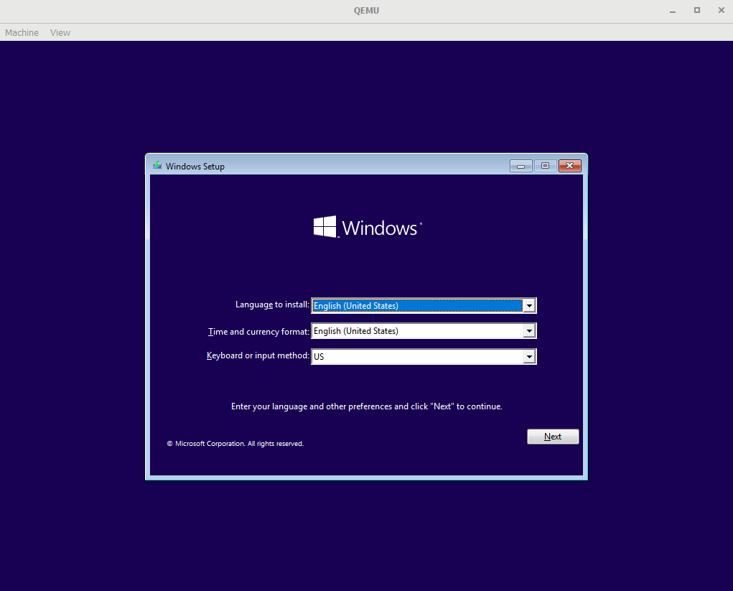

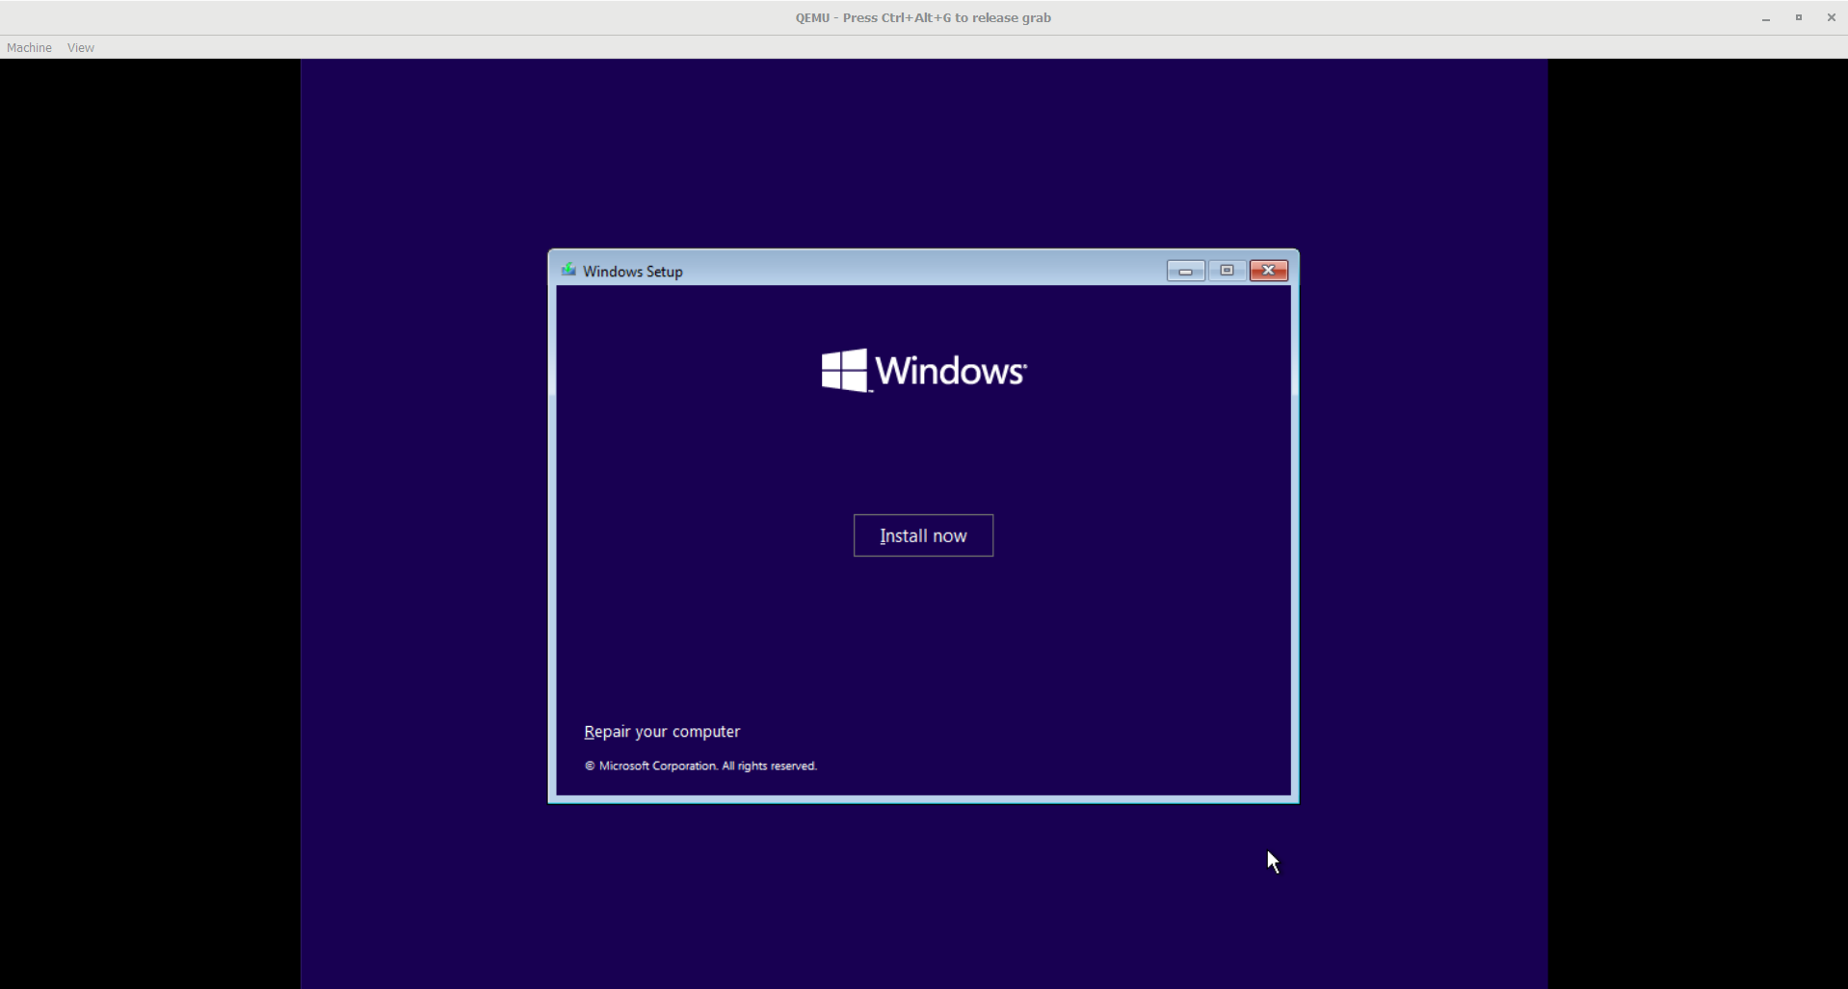

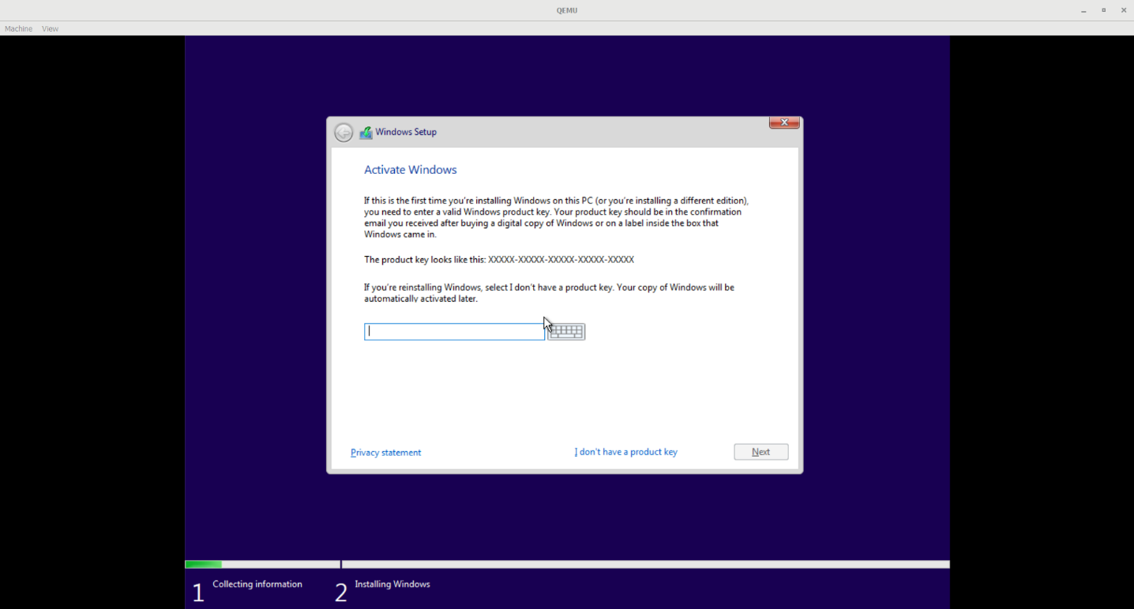

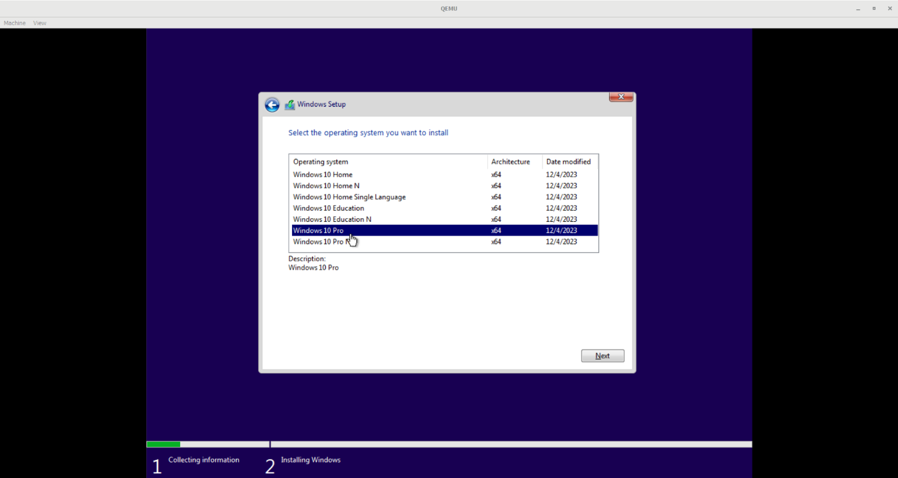

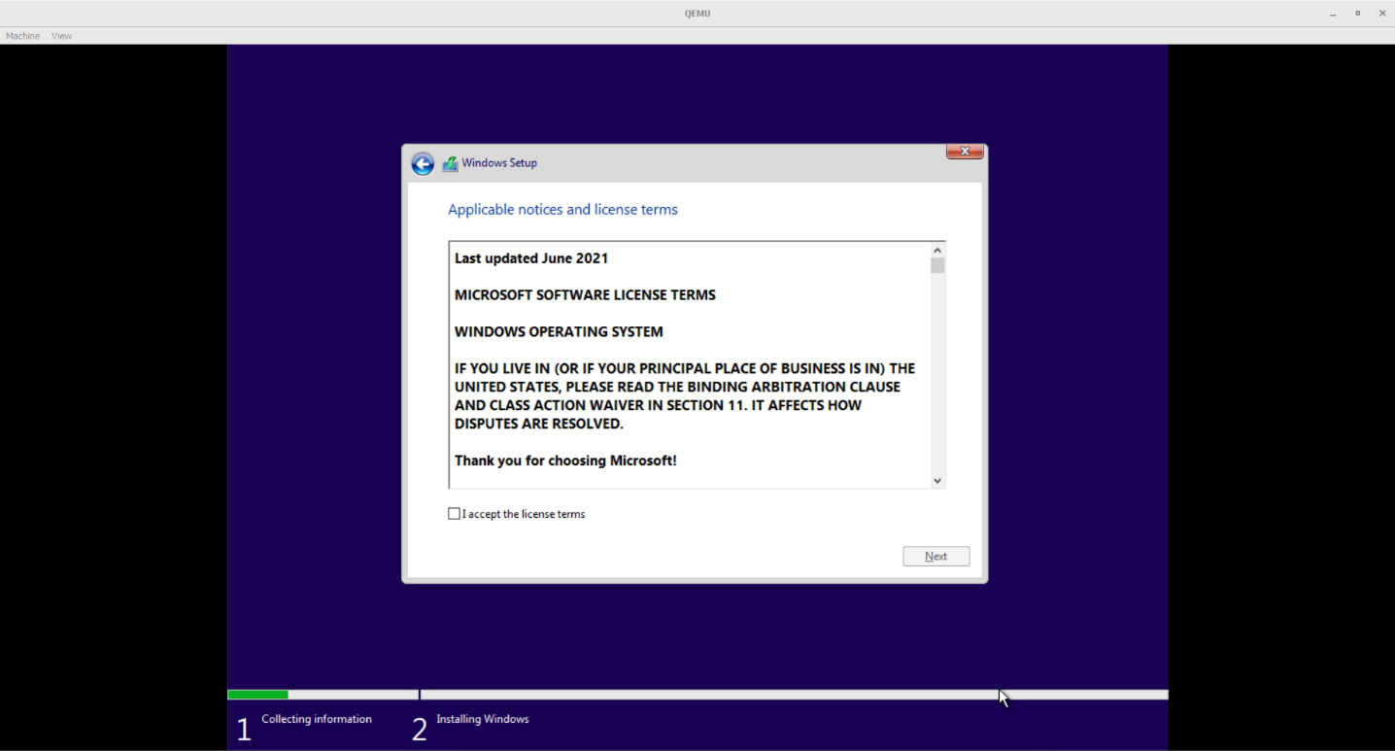

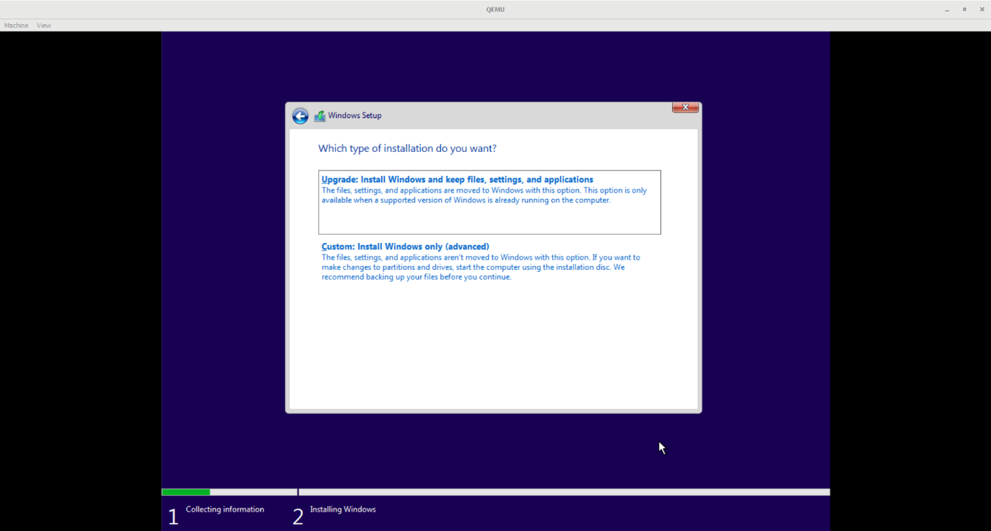

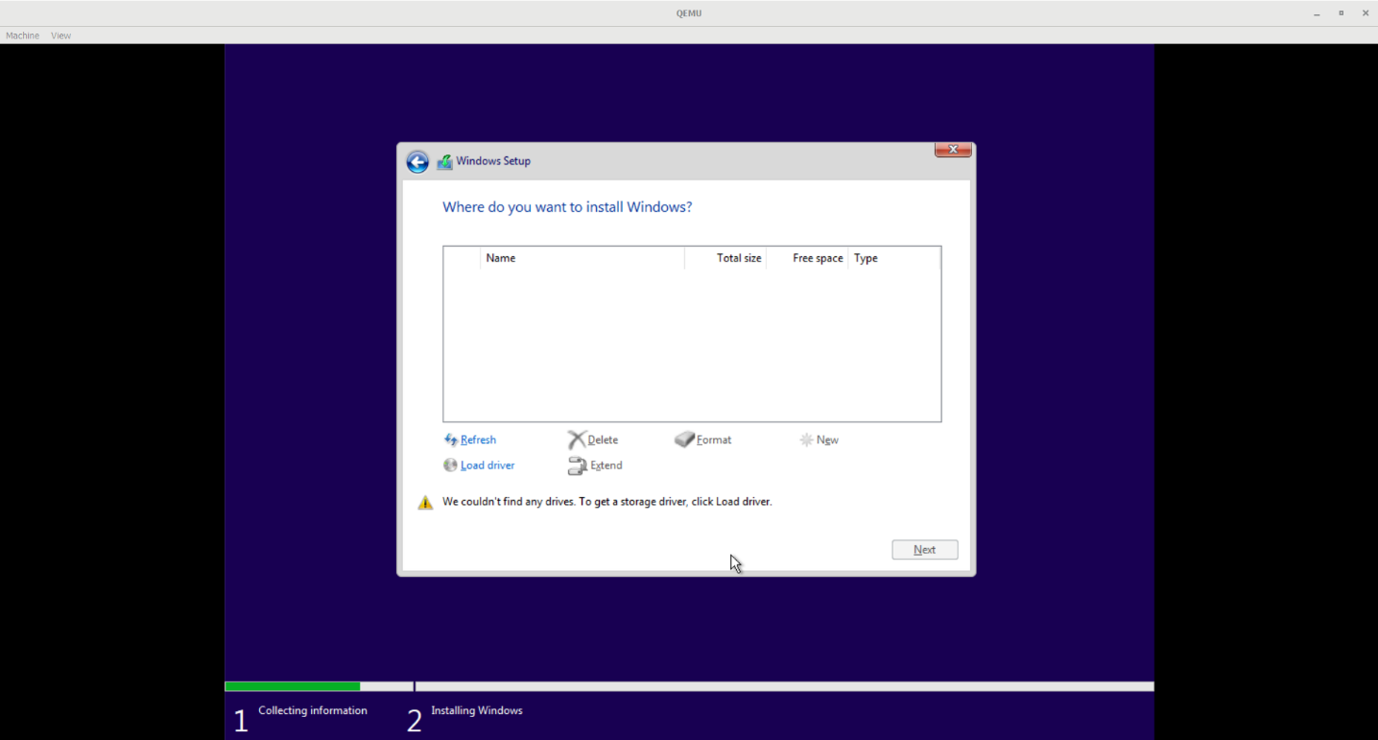

In this step, it doesn't recognize the disk we created. The reason for this is that sometimes it can't detect the SCSI drivers. We need to manually load them. We have already mounted the ISO in CD-ROM format to the virtual machine. Now, we go to **Load Driver > Search**, find our ISO, and from it, we select the **viostor** folder, choose the appropriate operating system and architecture, and click **Install**. Once the driver is successfully installed, the disk is detected correctly. Now, let's proceed with the steps.

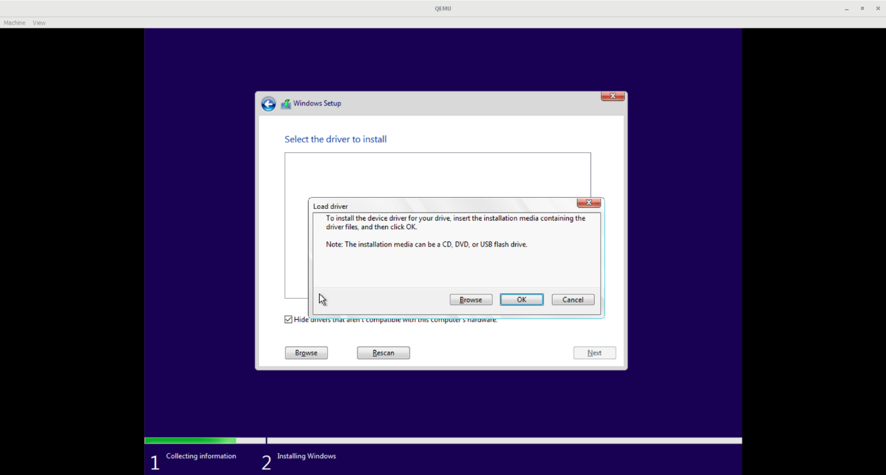

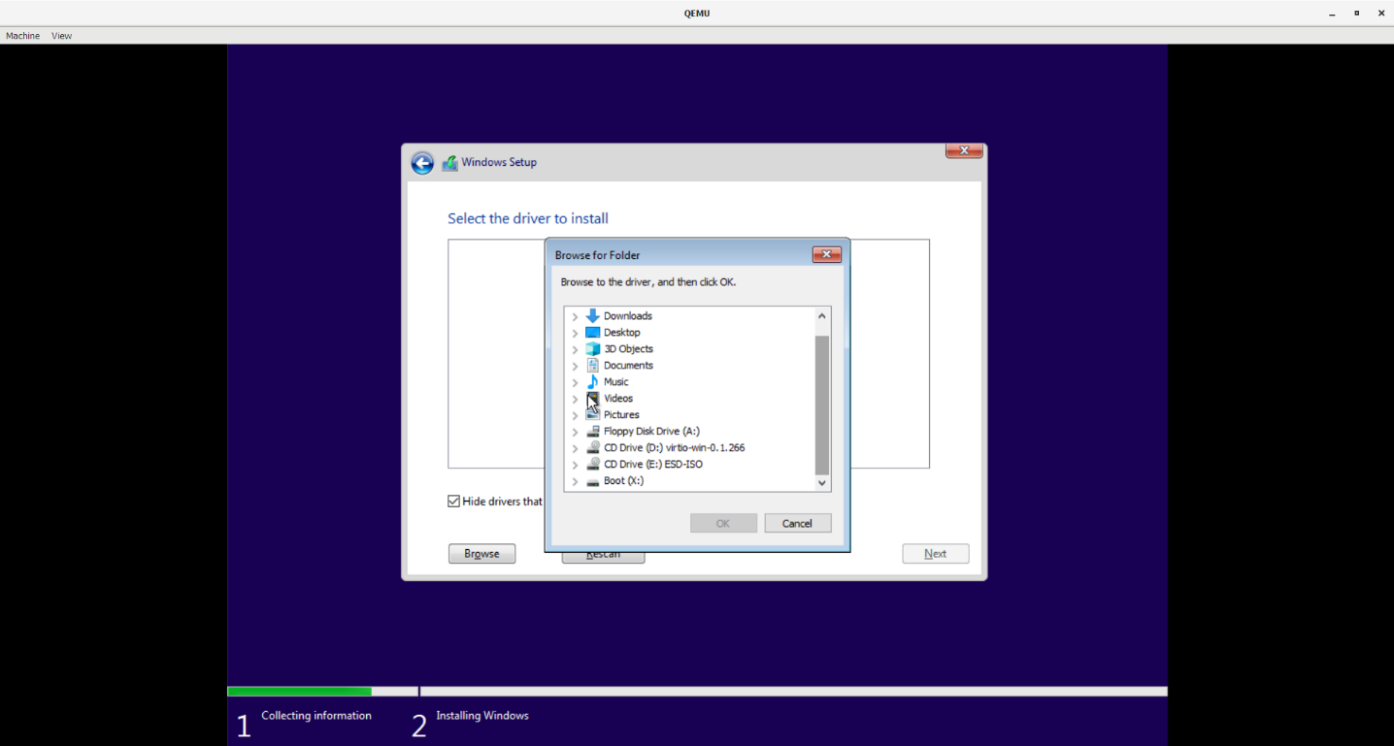

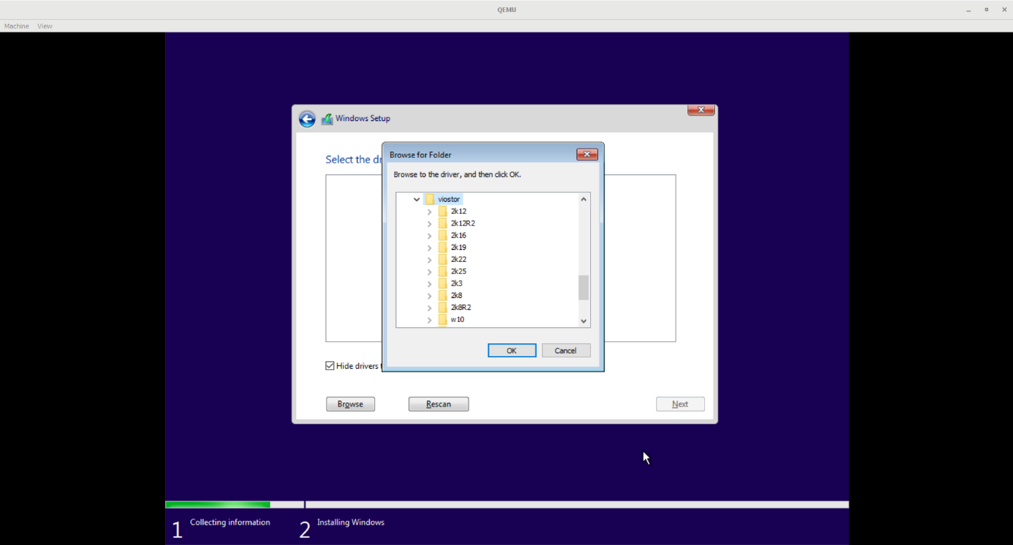

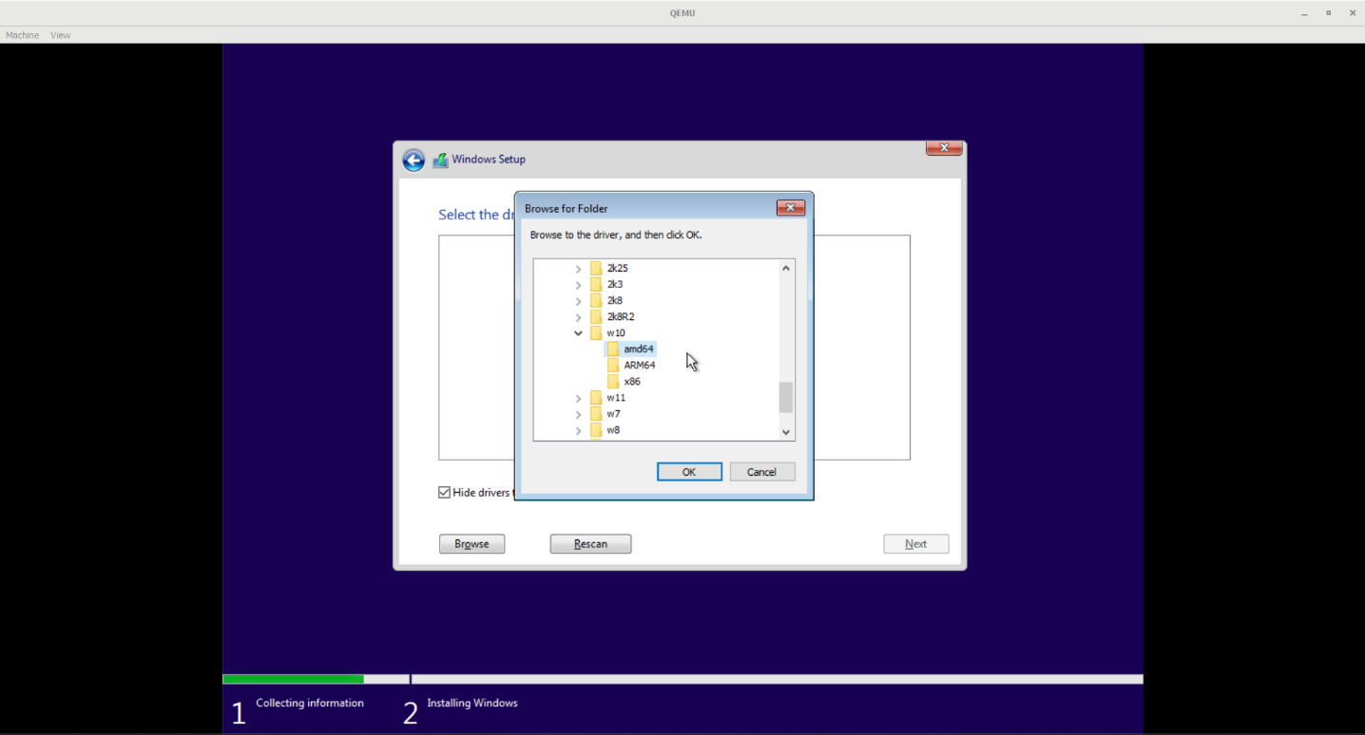

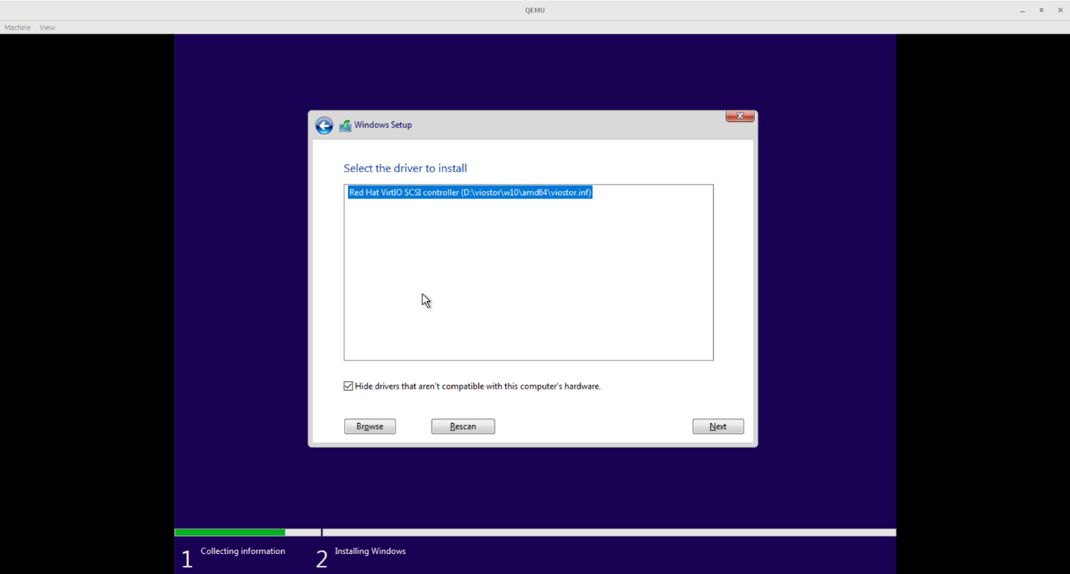

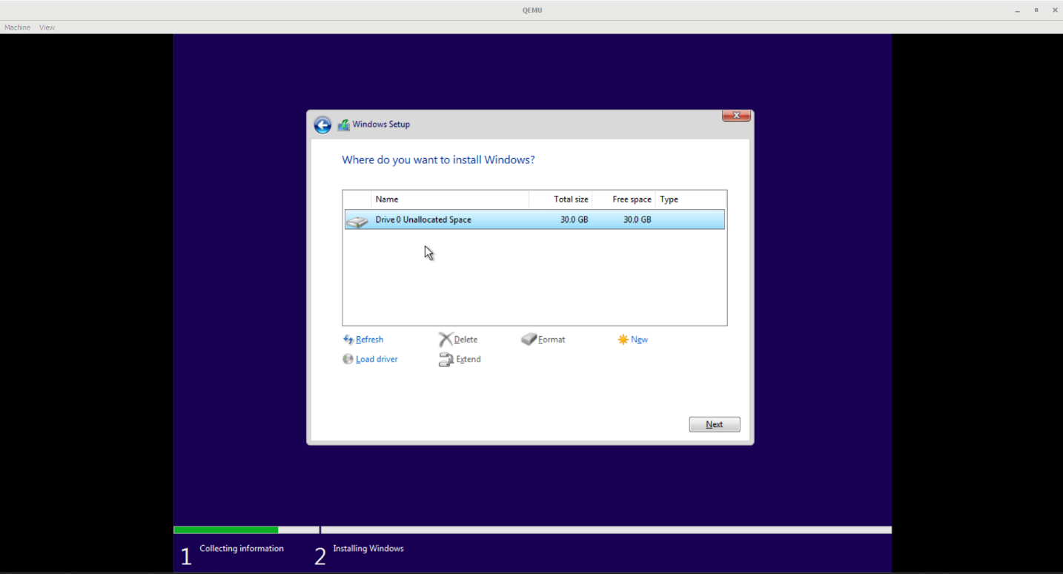

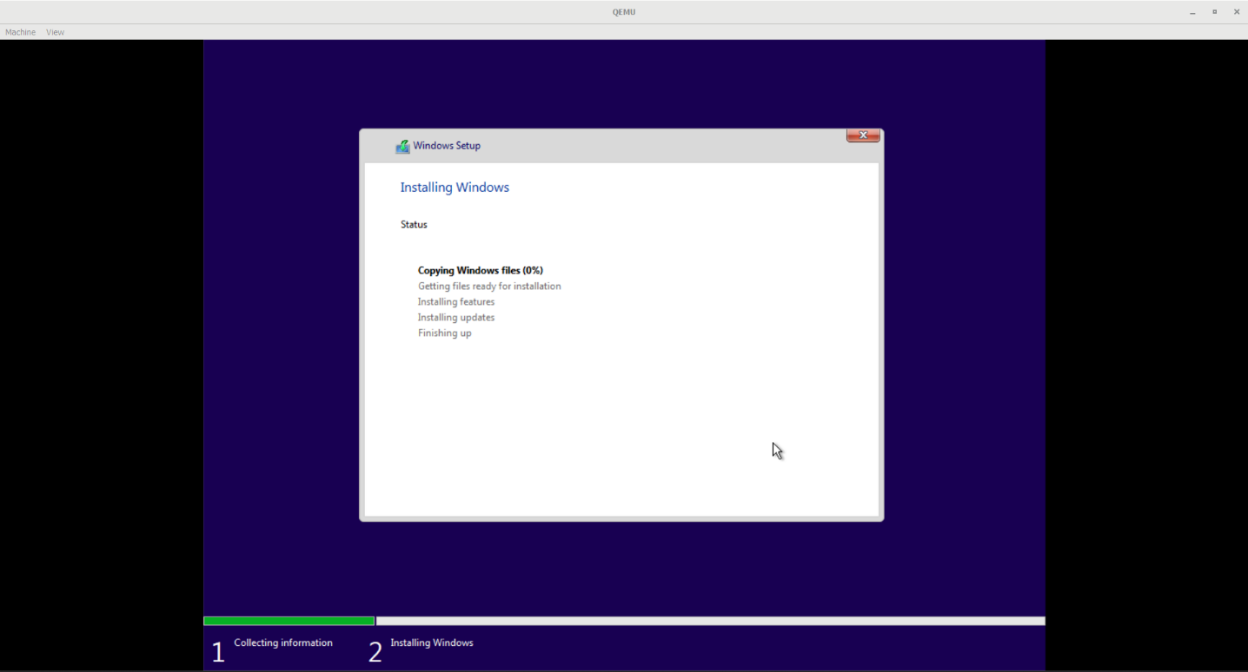

And the installation has started.

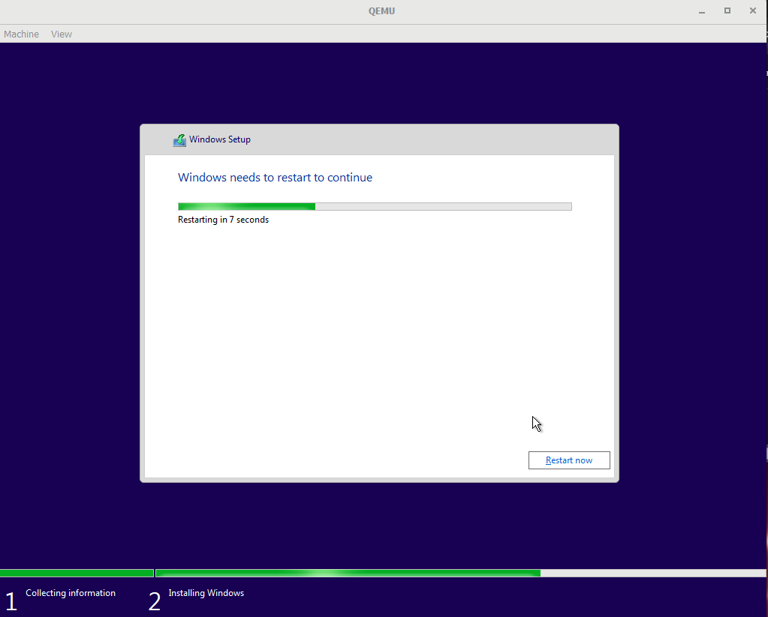

After the installation, the system will restart. During this time, we need to completely shut down the virtual machine, remove the ISO file, and restart it, otherwise, it will take us back to the installation screen.

Let's enter the following command:

**.\qemu-system-x86_64 -drive file=disk.qcow2,format=qcow2 -accel whpx -boot d -m 8G -cpu Westmere**

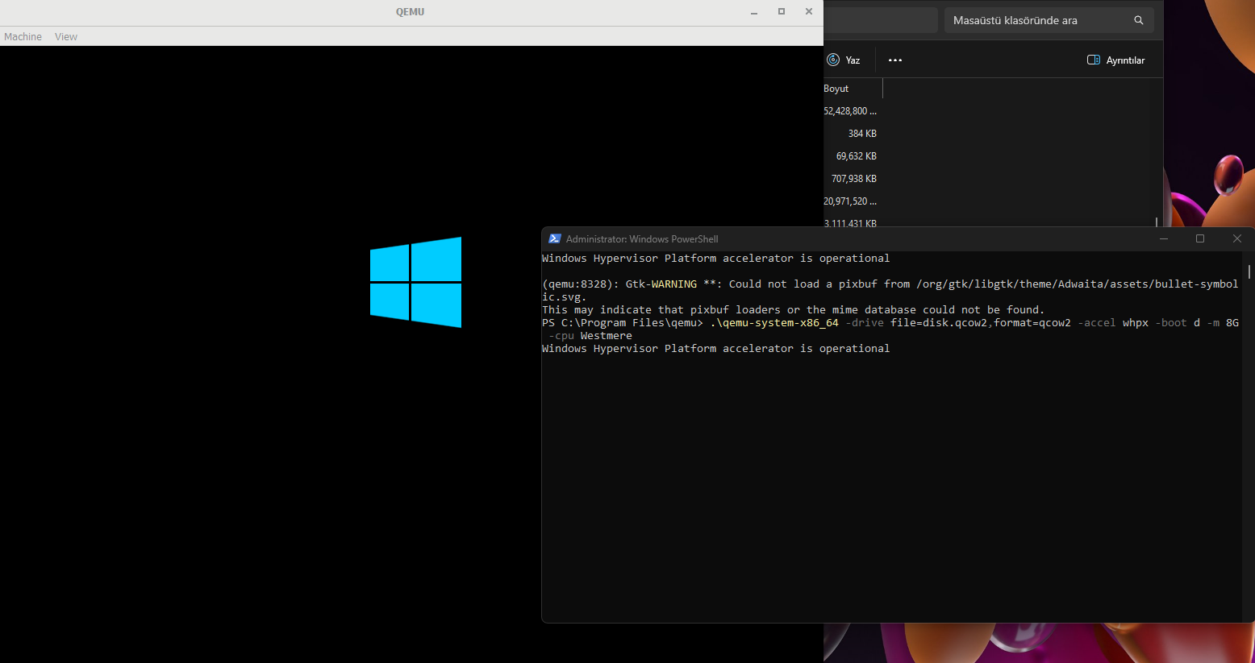

And our virtual machine has successfully restarted. After waiting for a while, Windows is successfully installed and we are greeted with this screen:

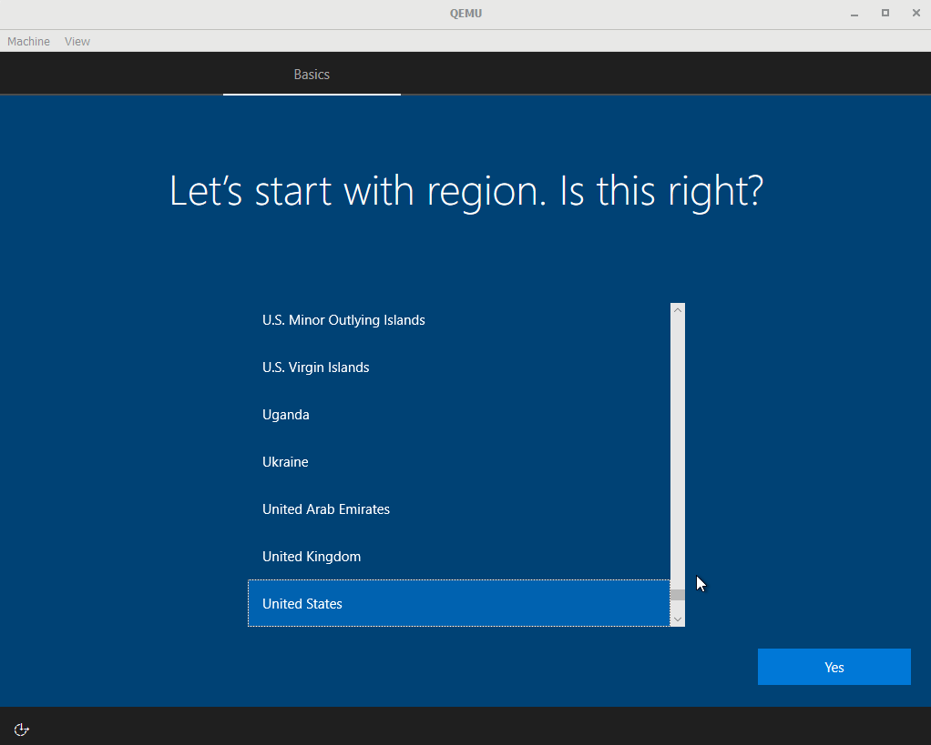

And after making the necessary configurations, the Windows desktop is displayed, welcoming us.

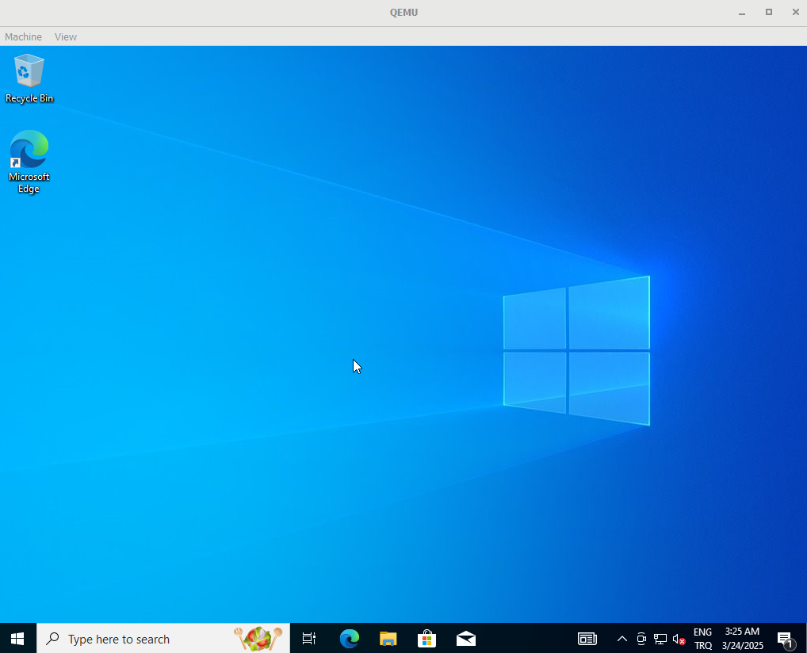

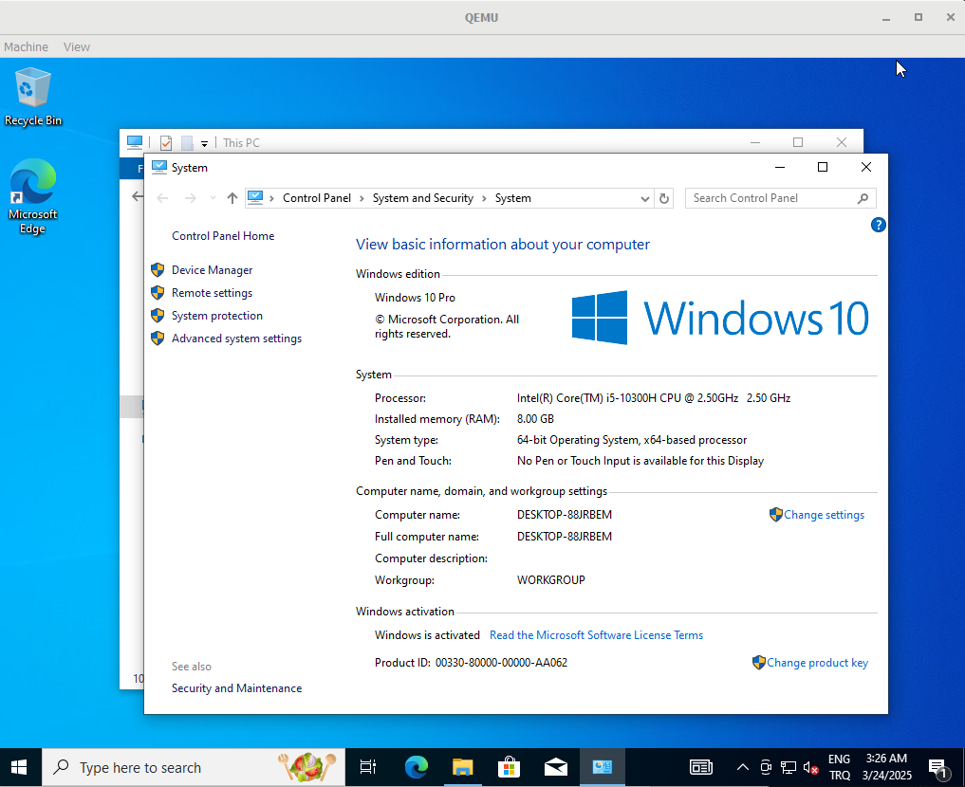

And now, our virtual machine is set up according to the specifications we provided.

So, here are the steps for setting up a virtual machine with QEMU using the WHPX accelerator. First, we install QEMU on our Windows computer. Then, we go to the installation folder (or we can directly add it to the system variables' path to access it directly using **qemu-system-x86_64**). After entering the necessary parameters into the application, we run our virtual machine. Once the operating system is installed, we shut down the virtual machine, remove the ISO file, and restart it to complete the installation. That's it**. Thank you for reading!**